NAME: SACHIN HANSDA
ROLL NO. : 111601019

DBMS LAB 3

1. Alter table: add one column ​ gender ​ to student table that can take either ‘M’ or ‘F’. Drop
the column. Add one column ​ age ​ to student table with default value 0.

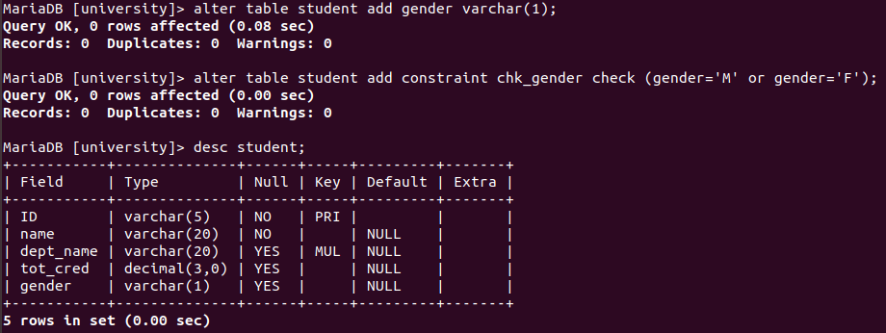
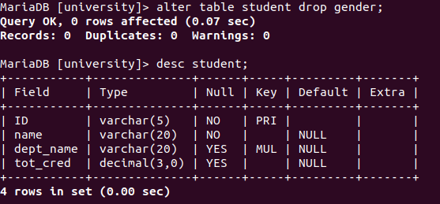
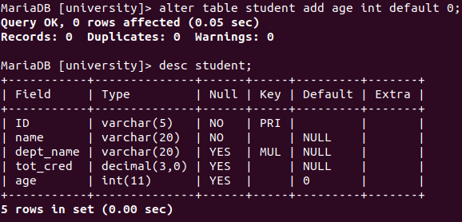

2. Update table: change age of students to 23 if their department is ‘Comp. Sci’.
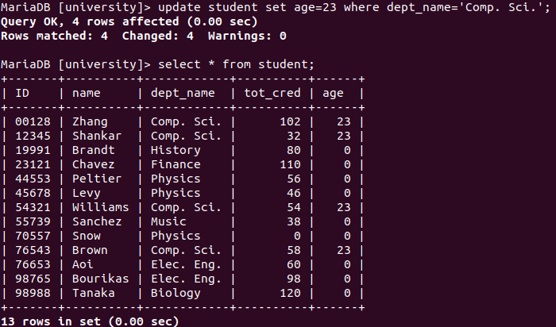

4. Show instructor table and give the 5 percentage salary hike to the instructors whose
salary is less than 70000 and department is either Music or Physics.
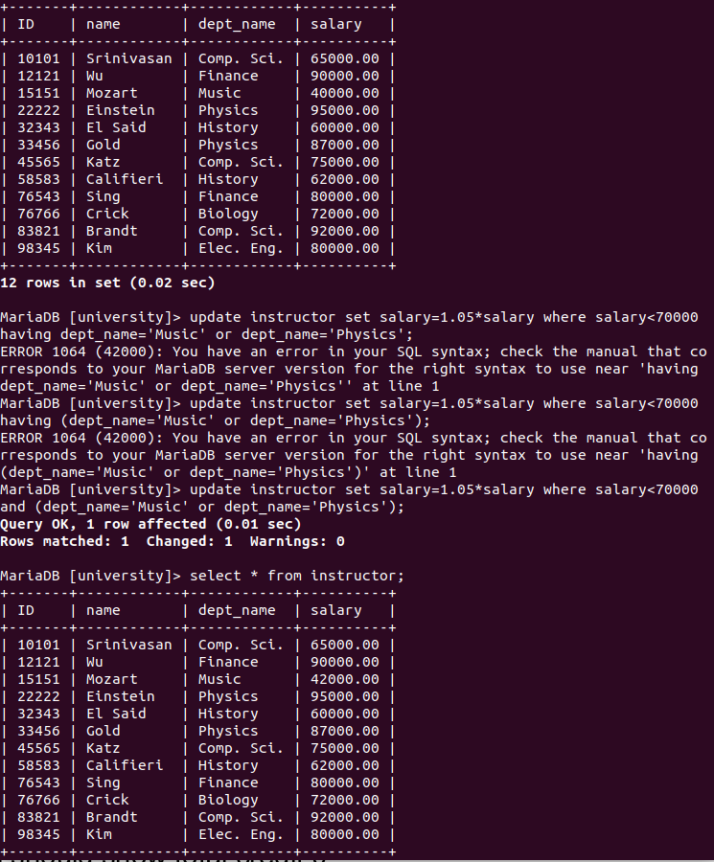

6. Show the 6th and 7th highest paid instructors.
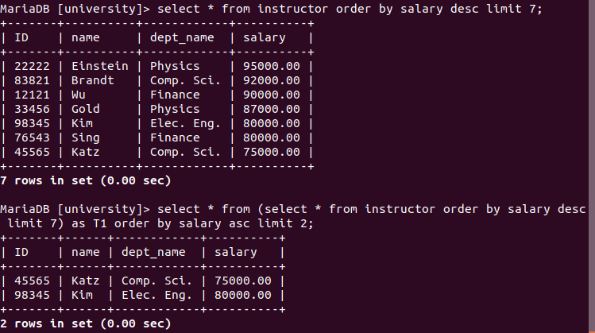

7. Show the instructors whose department is in Taylor, Watson or Painter;
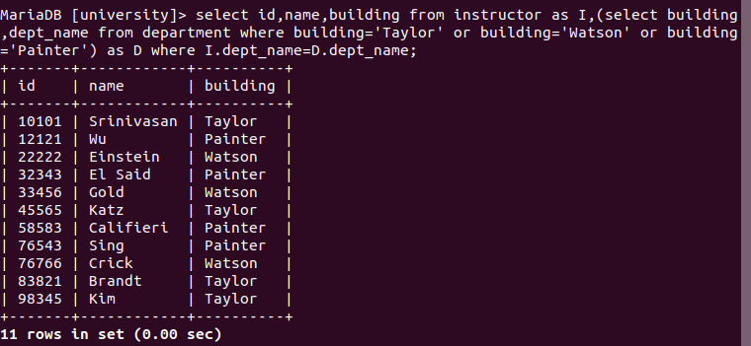

8. Show the name of the students whose total credit is between 7 and 14. Do not use
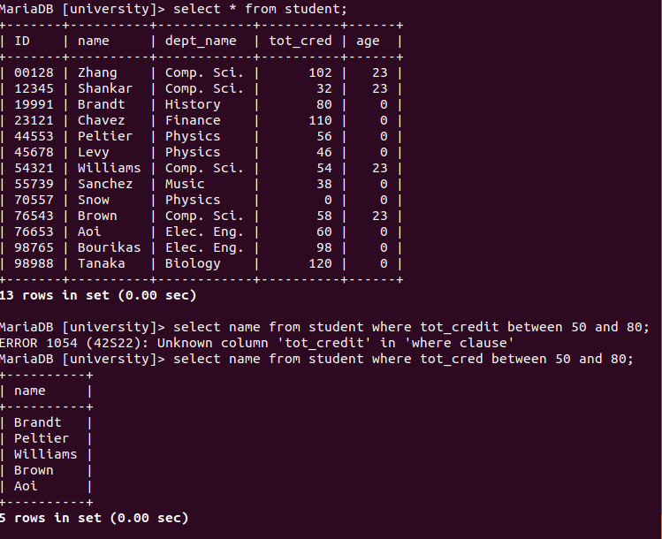
comparison operators (<,>).

10. Show the records of the students whose name starts with B excluding Brown.
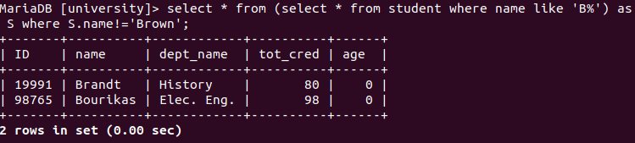

11. Show ID, name, courses, and corresponding credits of each student
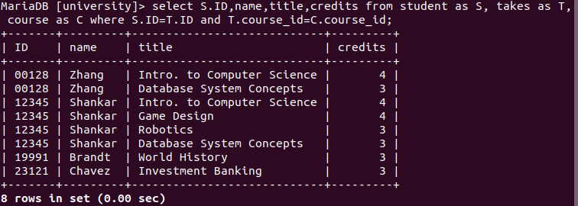

12. Find sum of total credits for all students.
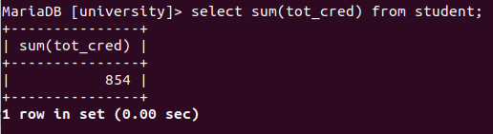

13. Find the departments with the maximum budget.
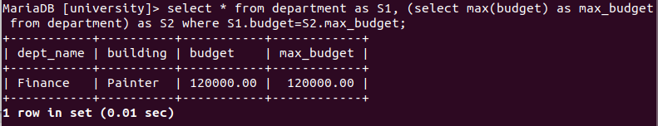

14. Find the department with highest average salary paid to the instructors.
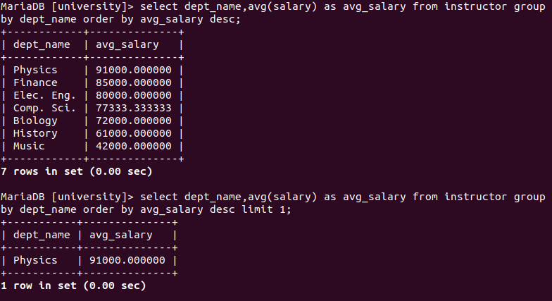

15. Show name, and salary of instructors in Finance and Biology in descending order of
salary.
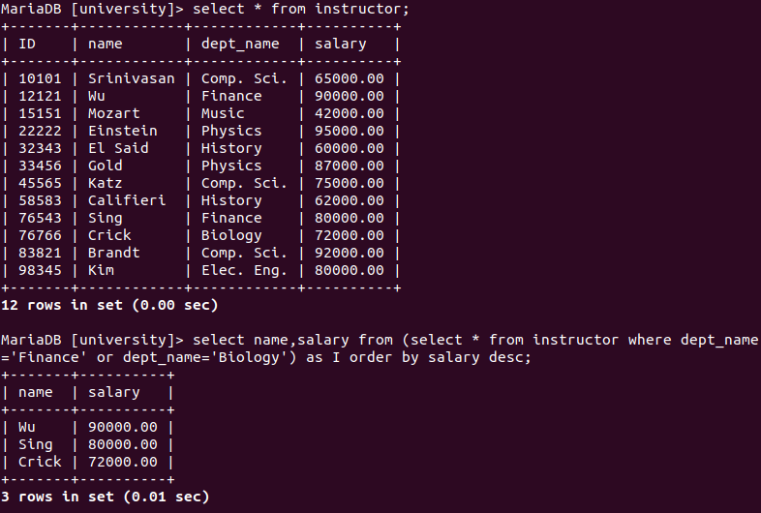

16. [B] Find name of instructor whose salary is greater than salary of all instructors belongs
to either Biology or History or Finance department.
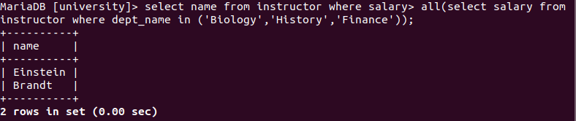

17. Correct the tot_credit attributes for each tuple in student table such that total credit is
equal to the credit of courses successfully completed by the student. Here successfully
completed means student has a grade that is not ‘F’ . Students who did not take any
courses, the output for them should show total credit 0.
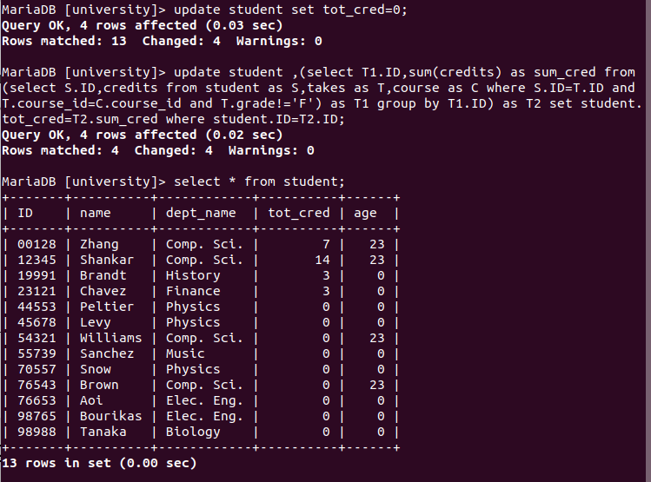

18. Create view of students who are studying in a department with budget more than 80000.
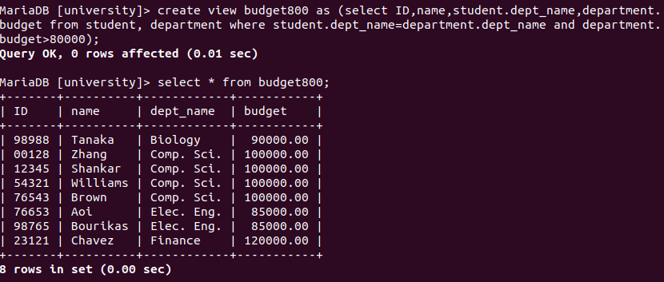

19. Insert a new student information in student table ID is 98761, name is ‘Raman’ and
dept_name is ’Music’
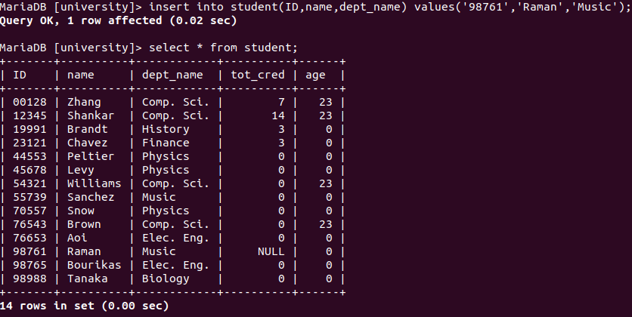

20. Create a view containing tot_cred attributes of students
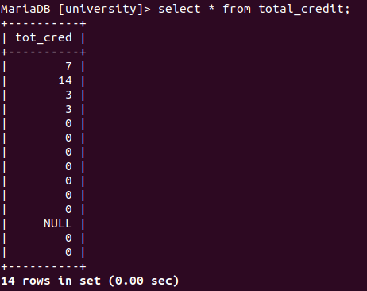

22. Create view stud_dept_budg containing students, department names and budgets
where students are studying in a department with budget more than 80000.
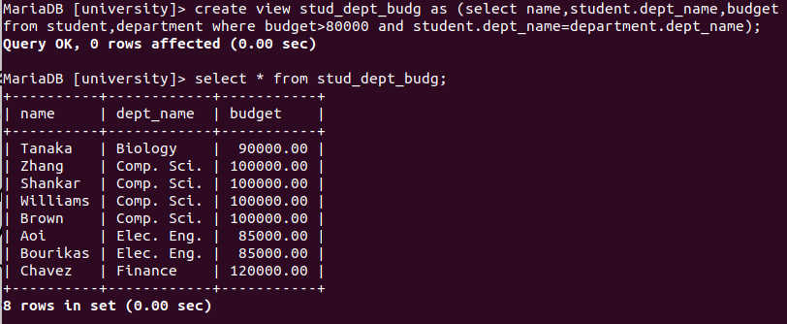

23. Decrease the budget of the Biology department by 10000.
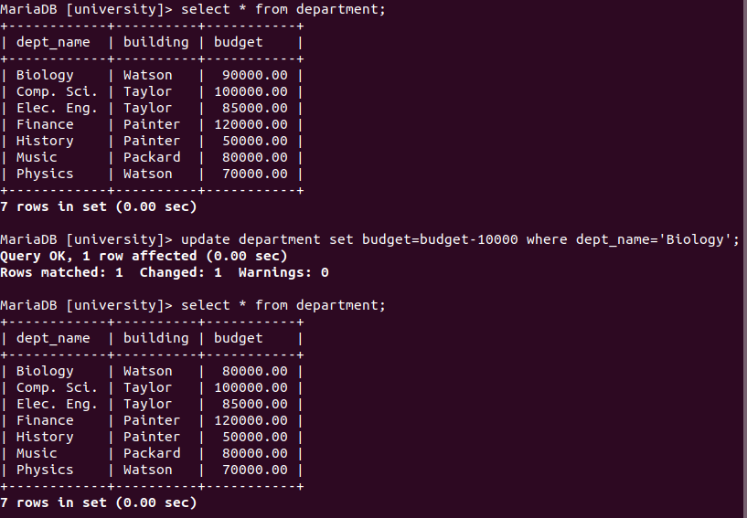

24. Show the content of stud_dept_budg.
